Aim :- Study and Implementation of Single-Sign-on

Theory:-

* Single sign-on (SSO) is a [session](https://searchmicroservices.techtarget.com/definition/session) and user [authentication](https://searchsecurity.techtarget.com/definition/authentication) service that permits a user to use one set of [login](https://searchsecurity.techtarget.com/definition/logon) credentials (e.g., name and password) to access multiple applications.
* The service authenticates the end user for all the applications the user has been given rights to and eliminates further prompts when the user switches applications during the same session. On the back end, SSO is helpful for logging user activities as well as monitoring user accounts.
* In a basic web SSO service, an [agent](https://searchenterpriseai.techtarget.com/definition/agent-intelligent-agent) module on the application server retrieves the specific authentication credentials for an individual user from a dedicated SSO [policy server](https://searchsecurity.techtarget.com/definition/policy-server), while authenticating the user against a user [repository](https://searchoracle.techtarget.com/definition/repository) such as a lightweight directory access protocol ([LDAP](https://searchmobilecomputing.techtarget.com/definition/LDAP)) directory.

Procedure:-

Step1: got to the following link <https://auth0.com/learn/how-to-implement-single-sign-on/>

Step2: click on try autho for free → fill the details



Step3: Provide the username and Password and click on Signup

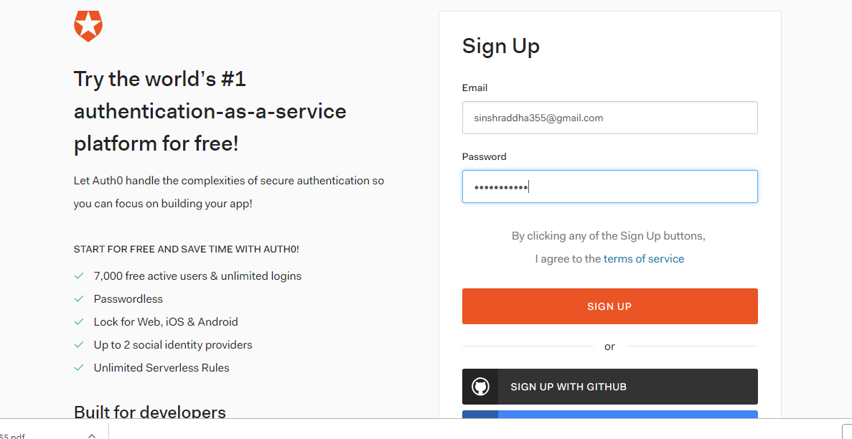

Step 4: Provide the tenant name and click on next

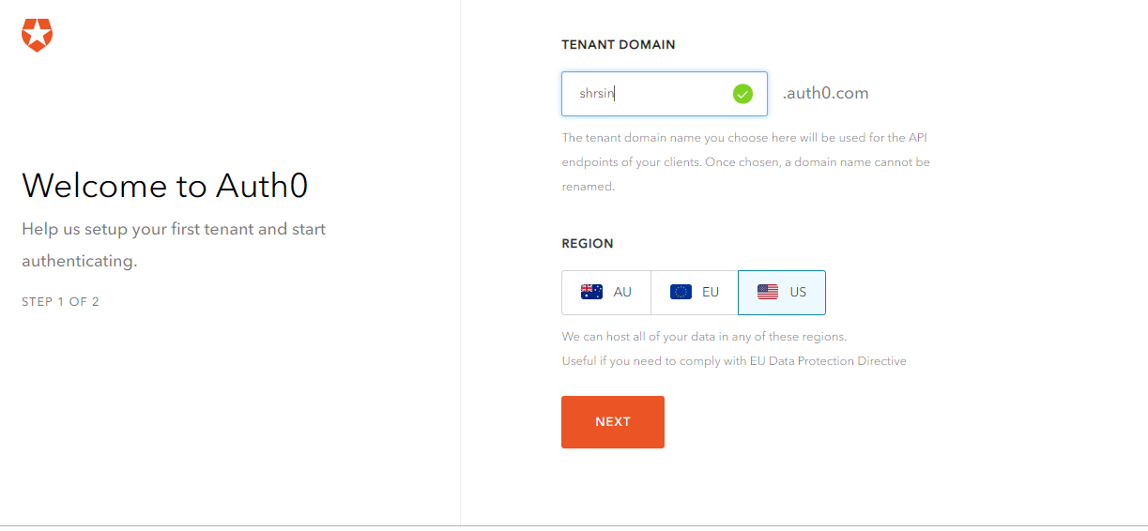

Step5: Fill all the Details and click on create account



Step6: In this step you will get Dashbord . First create one user

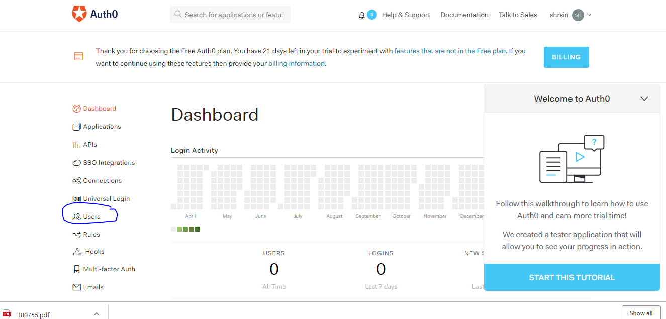

Step 7: click on create user

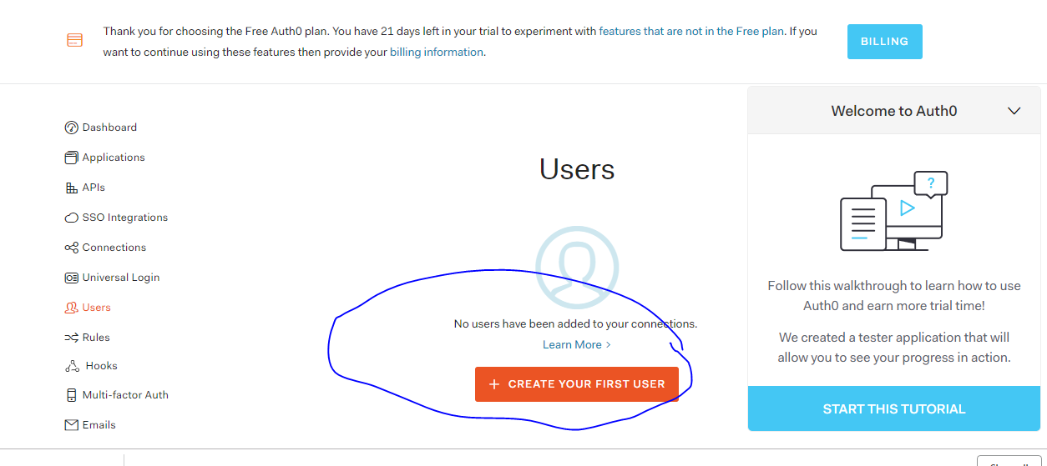

Step 8: fill all the details and click on save

Step 9: now click on Start this tutorial and click on next.

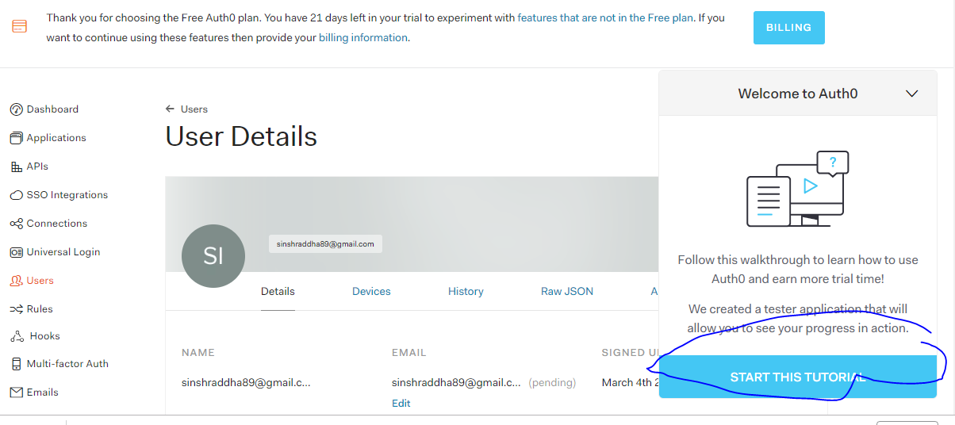

Step 10:- In this step click on test new user login and click on next

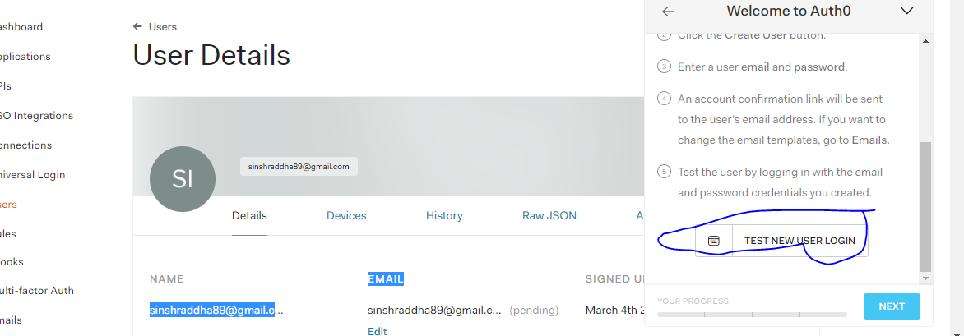

Step11: in this step provide username and password



Step 12: Result

